Dominion Oamen
CSIS 3744
Assignment 1

2. Cable Termination Practical

2.1 Cable Termination Steps

Preparation Phase
Step 1: Make sure your materials and tools are all available. The materials and tools used are:
- Cat5/Cat5e cable
- RJ45 connector
- Crimping tool
- Boot(informally called “jacket”)

Step 2: Identify the ANSI/TIA cabling standard you are going to use. For the practical, we used the T568A standard, which follows this format:

Pin | 1 | 2 | 3 | 4 | 5 | 6 | 7 | 8
Colour | Green/White | Green | Orange/White | Blue | Blue/White | Orange | Brown/White | Brown

Termination Phase
Once all preparations are done, we can start the termination process.
Step 1: Use the stripping notch on the crimping tool to remove the outer jacket of the Cat5e cable, revealing the four twisted pairs.
Step 2: Untwist the pairs and arrange them in order following the standard chosen in the preparation phase, then cut across the arranged cables so they are all flush. Then put the boot on the cable before installing the connector.
Step 3: Choose your RJ45 connector and turn the clip side away from you, facing the gold pins towards you. Slide the already cut and arranged cables into the RJ45 connector, making sure it is all the way in.
Step 4: Slot the RJ45 connector into the 8 pin slot of the crimping tool and crimp hard. It is recommended to have a small part of the outer cable jacket inside the RJ45 connector so it is more durable, but a good crimp will also make it durable.
Step 5: Wear the boot(jacket) to protect the connection and give it a gentle tug to ensure your crimping was solid.
Step 6: Repeat the process on the other end of the cable. There are two approaches:
- Crossover: This is when a different standard is used at the two ends to connect the same type of devices. In computer networks today, we have new network ports called Auto MDI-X (Automatic Medium-Dependent Interface Crossover), which automatically detects whether a cable is straight through or crossover. Because of this, we do not go through the stress of crossovers; we stick to straight through.
- Straight through: This is when the same standard is used in the termination of both ends of the cable.
Step 7: Do a continuity test: run your cable through a continuity tester to check that it is connected efficiently.

2.2 Practical Lessons

Teamwork makes the dream work.
I learnt that teamwork makes the dream work. Our team divided the termination process so that each person handled a specific part. I stripped the outer jacket, though I initially made a mistake by using the clipping side of the crimping tool, which meant we had to cut the cable and re-strip it. Two of my teammates handled the untwisting and arrangement of the wires, after which I confirmed the correct pin order and inserted the cables into the RJ45 connector. The remaining two teammates completed the crimping on both ends. Working this way allowed us to catch and correct mistakes early, and it made the overall process faster and more accurate than if one person had tried to do it all alone.

The importance of standards(ANSI/TIA).
Something else I learnt was how pre-set standards, like T568A, made the process faster. Because the wiring order was already defined, we didn't need to spend time figuring it out ourselves or debating how to arrange the pairs. This showed me that standards are a great example of how organisation makes work faster, not just for the person following them, but for everyone else involved too. It might seem like a small detail, but agreeing on a shared standard beforehand made a noticeable difference to how quickly and smoothly the whole team could work together.

2.3 Questions That Arose
Question 1: Why don't we strip the individual wires before crimping, only the outer jacket?
Answer: The gold contacts inside an RJ45 connector are not smooth pins that require bare copper to make a connection. They are small metal blades that pierce through the insulation of each individual wire during crimping, a method known as insulation displacement contact (IDC). Stripping the individual wires beforehand would actually weaken the connection, since the insulation normally helps hold each wire snugly in its channel, and bare copper is more prone to shifting, snapping, or shorting against a neighbouring pin during the crimp.
Question 2: Why do we have two different standards, T568A and T568B, if the cable colours are the same?
Answer: Both standards use the same eight coloured wires; the difference lies only in the order the green and orange pairs are pinned, while the blue and brown pairs stay in the same position in both. T568A is required for U.S. federal contracts and provides backward compatibility with older telephone wiring, while T568B descends from an older AT&T standard and became the more common choice in commercial installations. Electrically, the two standards perform identically, what actually matters is that the same standard is used consistently on both ends of a cable, since mixing the two intentionally is what creates a crossover cable.

3. Command Prompt Network Investigation

3.1 IP Address, Subnet Mask, and Default Gateway
Running the ipconfig command lists every network adapter on the device, both active and inactive. Two adapters returned a live configuration. The first, an Ethernet adapter, is a VirtualBox Host-Only Adapter used for virtual machine communication and does not connect to the internet, which is why it has no default gateway. The second, the Wi-Fi adapter, is the device's actual active network connection.
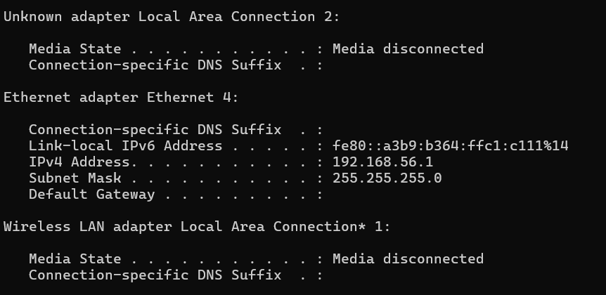
Figure 1: ipconfig output showing the VirtualBox host-only Ethernet adapter.
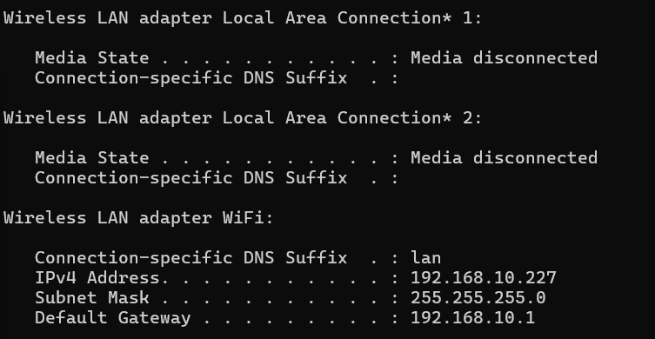
Figure 2: ipconfig output showing the active Wi-Fi adapter.
The relevant configuration values for the active connection are as follows:
Field | Value
IPv4 Address | 192.168.10.227
Subnet Mask | 255.255.255.0
Default Gateway | 192.168.10.1

3.2 Ethernet or Wi-Fi Link Speed
Question: What is your ethernet or Wi-Fi link speed?
Since ipconfig does not display link speed, the command netsh wlan show interfaces was used instead, as the device connects to the network over Wi-Fi. This command returns detailed information about the wireless adapter, including the negotiated receive and transmit rates.
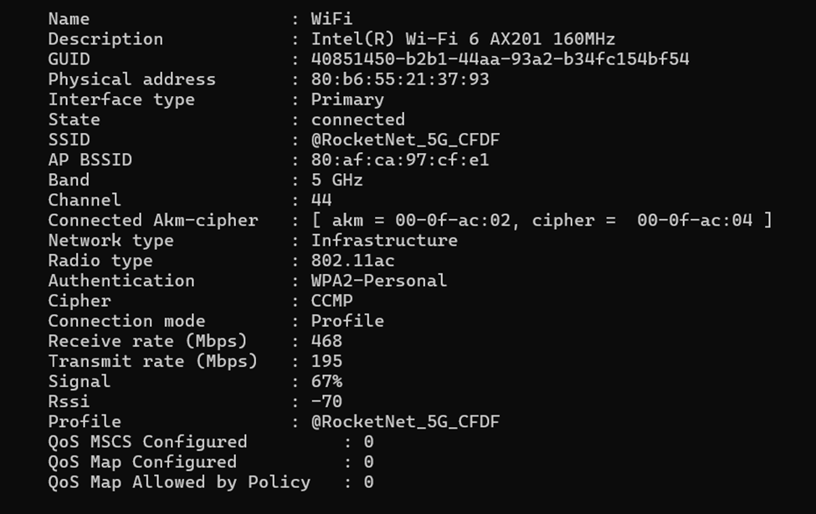
Figure 3: netsh wlan show interfaces output showing adapter and link speed details.
Field | Value
Adapter | Intel(R) Wi-Fi 6 AX201 160MHz
Radio type | 802.11ac
Band | 5 GHz
Receive rate | 468 Mbps
Transmit rate | 195 Mbps

3.3 IP and MAC Addresses of Other Devices on the Network
Question: List the IP and MAC addresses of at least two other active computers or devices connected to your local network.
The arp -a command was first used to display the ARP cache, which lists the IP and MAC (physical) addresses of devices the computer has recently communicated with. However, this command only reflects devices already present in the cache; it does not actively scan the network. The initial result returned only one other active device besides the default gateway.
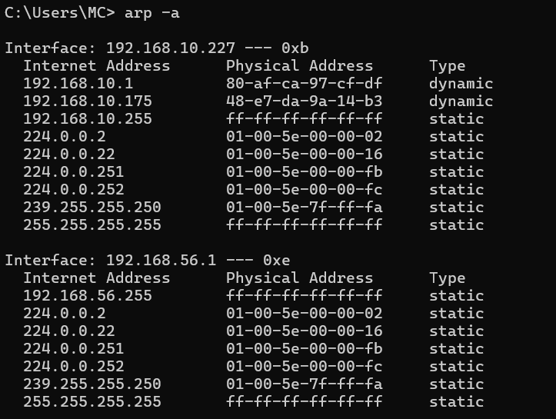
Figure 4: initial arp -a output showing only one other active device on the network.
To populate the ARP cache with additional devices, a ping was sent to the network's broadcast address (192.168.10.255), prompting devices on the subnet to respond at the ARP level even though Windows does not return an ICMP reply to broadcast pings by default.
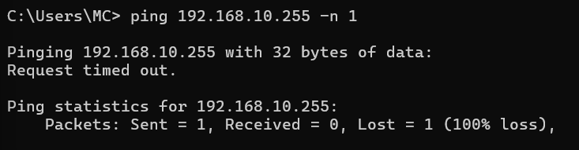
Figure 5: broadcast ping sent to 192.168.10.255 to prompt ARP responses from devices on the subnet.
Running arp -a again afterward revealed a new device that had not appeared in the cache before.
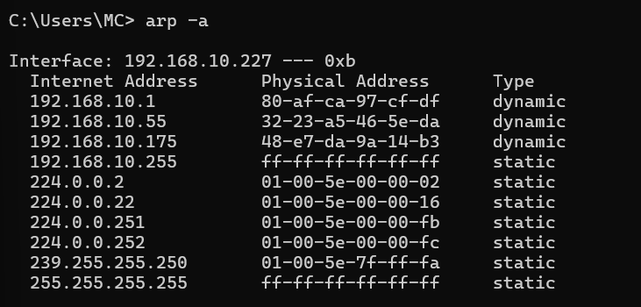
Figure 6: updated arp -a output showing a new device added to the ARP cache after the broadcast ping.
The IP and MAC addresses of the two other active devices identified on the network are as follows:
IP Address | MAC (Physical) Address
192.168.10.55 | 32-23-a5-46-5e-da
192.168.10.175 | 48-e7-da-9a-14-b3

3.4 Reachability of Identified Devices
Question: Are the devices identified in Question 3.3 reachable from your computer? Justify your answer using the appropriate Command Prompt command and its output.
The ping command was used to test reachability for both devices identified in question 3.3.
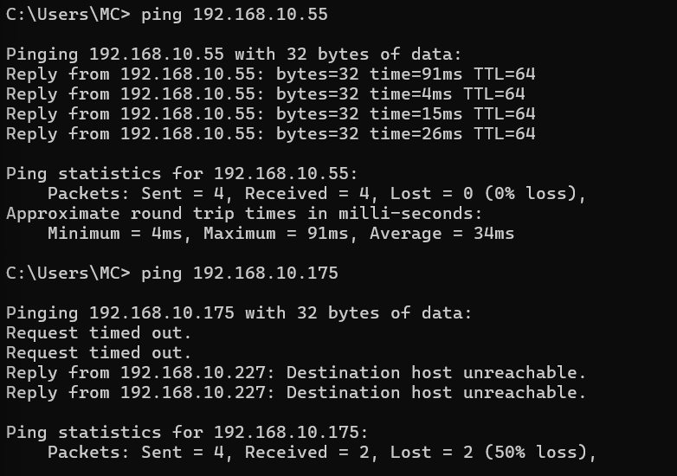
Figure 7: ping results for 192.168.10.55 and 192.168.10.175.
Device | Reachable | Justification
192.168.10.55 | Yes | All 4 packets received replies, 0% packet loss, round-trip times between 4ms and 91ms.
192.168.10.175 | No | 2 requests timed out and 2 returned "Destination host unreachable" from the local machine, 50% packet loss.

The device at 192.168.10.55 was fully reachable, confirming it was active and responding normally on the network at the time of testing. The device at 192.168.10.175 was not reachable despite appearing in the ARP cache. This is because the ARP cache is not a live view of the network; it stores entries from recent communication, so a device can remain listed for a period after it has gone offline or disconnected. The "Destination host unreachable" replies originated from the local machine itself (192.168.10.227), confirming that the device could not be located on the network rather than the request simply being dropped in transit.

